

Wednesday 12th November 2025 at 7.30pm
in The Reading Room, Castle Drive, Astley
__________________________________________________________________________

DRAFT MINUTES

Present: Chairman Cllr Webber (Chairman), Cllr Orton, Cllr Proctor, Parish Clerk Helen Billington.
Also in attendance: James Wilkinson, Jeanette Sutton, Adam Weaver

45/25
Apologies
Apologies received from Cllr Hunter

46/25
Open Forum
There was discussion about the obstruction caused by lorries to the Woodyard parking and delivering goods. There was a report of damage to the edge of the pavement and damaged tarmac due to tyres.
Adam Weaver offered to speak to Mrs DeMarco to try to resolve the issue.
Speedlines had been noticed recently in the 50mph area near the Nursery. It was felt it might have been more useful in the 30mph zone.
It was mentioned that Rachel Taylor, MP, may have access to HS2 funds which could be used to help improve the local highways, if Astley falls within an “affected” area.

47/25
Declaration of Interests
No conflicts noted

48/25
Minutes of meeting held on the 10thSeptember 2025
Minutes were confirmed as an accurate record of the meeting and signed by the Chairman.

49/25
Co-option of new Councillor
The Council unanimously voted for James Wilkinson to be co-opted to join the Council.
James has kindly agreed to join and completed his Declaration of Acceptance of Office.
A Decaration of Interests form was left with him to complete (clerk to arrange to collect and include on website).

50/25
Proposed meeting with MP
MP’s office has responded to the Clerk to thank the Council for the invitation to the January PC meeting.
However, her representative has suggested an earlier meeting even if only with the Clerk.
Clerk will liaise to identify an alternative date and suggest a Friday/local surgery day/Wed or Thursday evening, so that other members of the Council could also be present.
The main topics to be flagged to her were:
- HS2 funding or other fund to improve speed at the crossroads and general road safety
- Street lighting improvements (for residents as well as those staying at the castle

51/25
Highways update
Clerk reported that Scott Cameron was pursuing the local concerns about speeding, blind exits and road signs. Highways are apparently overwhelmed with work and there is no clear update so far. He will feed back any updates.
It was suggested a flashing speed sign with red/green alerts to the driver’s speed, might have an impact on speeding. It could be located near the Nursery on a pole.

52/25
WCC Councillor’s Delegated Budget
Cllr Proctor will ask Richard Fellows if he is aware of any highways issues.
Cllr Webber outlined the issues that could be captured within an application for this delegated budget.
It was reported the school sign is broken and could be replaced, potentially with a flashing sign as discussed in the update above 51/25.
Clerk will feedback to Scott Cameron regarding a request of a replacement school/speed flashing sign from his delegated budget.

It was mentioned that it would be helpful for the church to have a sign to help visitors.

53/25
Solar farm updates
No update has been received regarding current progress on Sole End or Astley Gorse Extension.

Clerk will check the planning application for any further information.

Adam Weaver reported that the local solar farm already under construction could be live by end of February 2026.

Clerk has investigated creating a Grants Policy so that when Sole End begins to make payments to the Community Fund, local organisations can apply to be considered.

54/25
Devolution update
Council work is in progress to decide on the new government structure, expected by early 2026.
Parish Councillors have had meetings information if they wish to be involved.

55/25
Defib update
Cllr Orton is investigating the cost of replacement pads, and the Clerk will check the records to see if there is any information filed.

56/25
Financial regulations policy

Cllr Webber had identified several elements for discussion from the adopted policy.

Most of the points are already captured in the data collected by the clerk and held ready to complete AGAR (the annual governance and accountability return) in May.

It was resolved that once a quarter, the bank reconciliation would be verified by one of the Councillors other than Cllr Webber and Cllr Orton (existing signatories).

Cllr Proctor reviewed and signed the reconciliation to Nov 2025.

The clerk agreed to feed back in January proposed budgets for salaries and any change required for the internal audit (completed in May prior to AGAR submission)

57/25
Clerk Report

- It was noted that Mr Fellow (groundsman) does not have any public liability insurance and the Council insurance does not cover non-employees.
Cllr Orton will verbally advise him that the Parish Council does not accept any liability for any injury or issues created because of the work done on their behalf.

- The Clerk has confirmed Warwick Record Office will hold the historical documents passed over by Cllr Proctor. These will be held on long term loan from Astley Parish Council, can be viewed by appointment for free, and may be withdrawn in the future for a small fee.
There was interest in viewing the journals before they are taken in, so Jeanette Sutton has borrowed them to read before passing back to the Clerk (or any other interested parties for viewing- please contact the clerk).
When this is completed, Clerk will take them to Warwick to be safely stored.

58/25
Finance
Cheque signed by signatories.
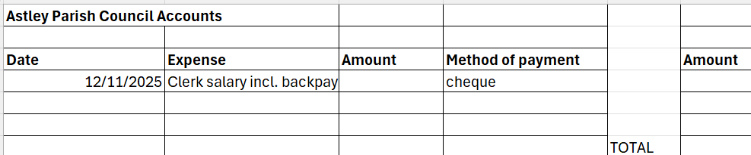

Clerk reported the balance in the account is £1287.44 which matched reconciliation.
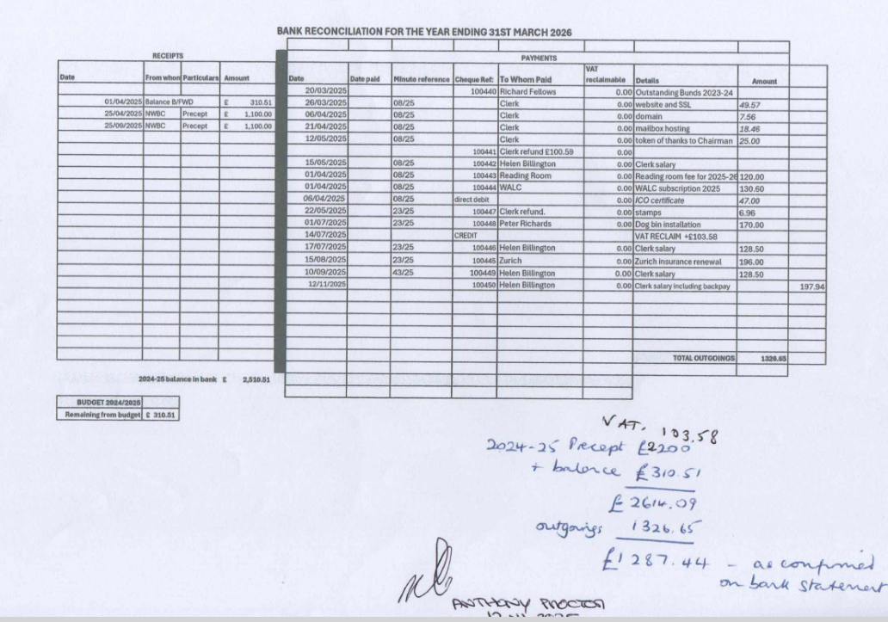

59/25
Councillors report/items for future agenda
There was discussion about Severn Trent markers and the implications of the work being undertaken. It was not clear what is happening locally.

Meeting closed at 8:58pm

The next meeting will be held at 7:30 pm on Thursday 15th January 2026 in The Reading Room Castle Drive, Astley.

Chairman signature Date

Draft created by
Helen Billington, Clerk,
November 13th, 2025

