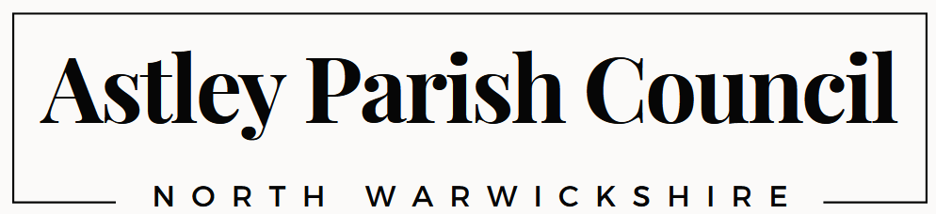

To all Electors of Astley Parish
Astley Parish Council will be hosting the
Annual Parish Meeting
on Thursday 21st May 2026 at 7.00pm
in The Reading Room, Castle Drive, Astley
___________________________________________________________________________________

Agenda

- Apologies for absence

- Reports from Community groups (including Astley Parochial Church Council) and County Councillor Scott Cameron

- Approval of minutes from meeting held 15th May 2025

- Chairman’s review of the year

- Report on annual finances (Clerk)

- Public discussion

- Any other business

Signed
Simon Webber

Chairman Astley Parish Council

11th May 2026

This meeting will be followed by the Astley Annual Council Meeting at 7.30pm

